**Project Documentation**

**Store Manager Inventory Project**

**1. Introduction**

Project Title: Store Manager Inventory System

Team ID: [Gopika7756]

Team Leader: HARINI . M [&muruganharini.9710@gmail.com](mailto:&muruganharini.9710@gmail.com)

Team Members:

Name & Mail ID

JACKLINE ZANDOUS [.U&jackline2611@gmail.com](mailto:.U&jackline2611@gmail.com)

Name & Mail ID

HARSHINI.C & [charshini097@gmail.com](mailto:charshini097@gmail.com)

Name & Mail ID

GOPIKA.K & [gopikakrishnank123@gmail.com](mailto:gopikakrishnank123@gmail.com)

**2. Project Overview**

**Purpose**:

* The Store Manager Inventory Project helps small businesses and store owners manage stock, track sales, and monitor purchases in real time.

**Features**:

* Add, update, and delete inventory items
* Sales and purchase tracking
* Low-stock alerts
* User roles: Admin & Store Manager
* Dashboard with analytics and reports

**3. Architecture**

* Frontend: React.js with Bootstrap and Material UI
* Backend: Node.js and Express.js for APIs and business logic
* Database: MongoDB stores inventory, sales, purchase records, and user account

**4. Setup Instructions**

**Node.js and npm**:

Node.js is a powerful JavaScript runtime environment that allows you to run JavaScript code on the local environment. It provides a scalable and efficient platform for building network applications.

Install Node.js and npm on your development machine, as they are required to run JavaScript on the server-side.

Download: <https://nodejs.org/en/download/>

Installation instructions: <https://nodejs.org/en/download/package-manager/>

**React.js**:

React.js is a popular JavaScript library for building user interfaces. It enables developers to create interactive and reusable UI components, making it easier to build dynamic and responsive web applications.

React.js, a JavaScript library for building user interfaces.

**Create a new React app:**

* create-react-app my-react-app
* Replace my-react-app with your preferred project name.
* Navigate to the project directory:
* cd my-react-app

***Running the React App:***

With the React app created, you can now start the development server and see your React application in action*.*

* *Start the development server:*
* npm start
* This command launches the development server, and you can access your React app at http://localhost:3000 in your web browser.

**5. Installation Steps**

* **Step 1: Initialize a new React application.**
* Use create-react-app or Vite for project setup.
* **Step 2: Install dependencies.**
  + Add tailwindcss, react, react-dom, and other necessary packages.

* **Step 3: Configure TailwindCSS.**
  + Set up the tailwind.config.js file.
  + Add the required styles in index.css.

**5. Folder Structure**

**6. Running the Application**

* **Frontend:**

cd client

npm start

* **Backend:**
* cd server
* npm start
* Access: Visit http://localhost:3000

**7. API Documentation**

**User:**

POST /api/user/register

POST /api/user/login

**Inventory**:

POST /api/items/add

GET /api/items/

PUT /api/items/:id

DELETE /api/items/:id

**Sales**:

POST /api/sales/add

GET /api/sales/

**Reports**:

GET /api/reports/stock

GET /api/reports/sales

**8. Authentication**

* JWT-based authentication for secure login
* Middleware for role-based access (Admin vs Store Manager)

**9. User Interface**

* Landing Page
* Inventory Dashboard
* Sales & Purchase Page
* Reports & Analytics
* Admin vs store manager)

**10. Testing**

* Manual testing during development
* Tools: Postman, Chrome Dev Tools

**11. Screenshot** 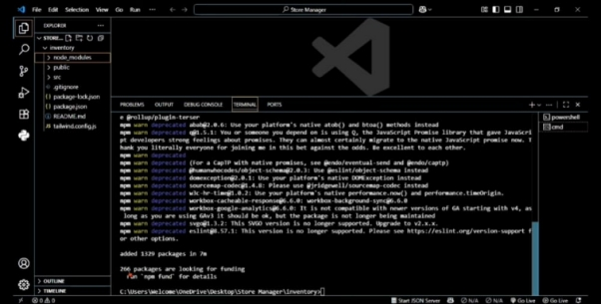

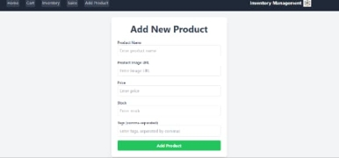

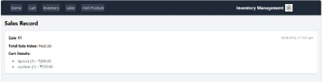

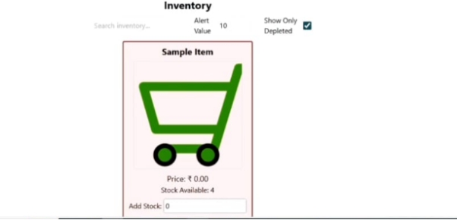

**12. Known Issues**

* To be listed during development/testing phase

**13. Future Enhancements**

* Barcode scanner integration
* Mobile app support
* Multi-store management
* Predictive stock alerts using AI